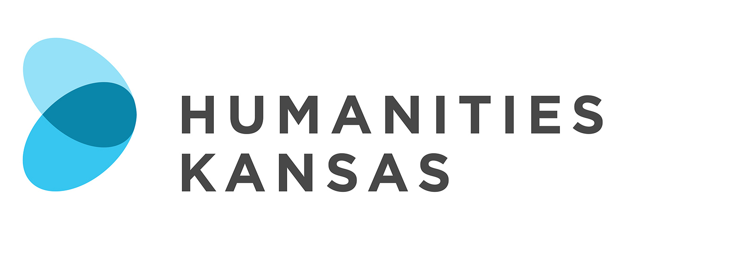

NEWS RELEASE

FOR IMMEDIATE RELEASE FOR MORE INFORMATION:
[DATE] [Insert your information here:
Local Project Director, Title and Organization
Phone Number and Email
Website]

Presentation Explores Emancipated African Americans’ “Free State” Experiences

[Community Name] – [Organization Name] in [Community Name] will host “Free Did Not Mean Welcome,” a presentation and discussion by Carmaletta Williams on [Date] at [Time] at [Location and Address of Presentation]. Members of the community are invited to attend the free program. Contact the [Host Organization Name] at [Phone Number] for more information. The program is made possible by Humanities Kansas.

[List any details about local event here]

Millions of African Americans walked away from the South after Emancipation looking for freedom. For some it meant a journey to Kansas, a “free state.” Discover how many realized that for Black people in Kansas “Free” did not necessarily mean “Welcome.”

Carmaletta Williams is the Executive Director of the Black Archives of Mid-America.

“Free Did Not Mean Welcome” is part of Humanities Kansas's Movement of Ideas Speakers Bureau, featuring presentations and workshops designed to share stories that inspire, spark conversations that inform, and generate insights that strengthen civic engagement.

-MORE-

Page 2 – Presentation Explores Emancipated African Americans’ “Free State” Experiences

For more information about “Free Did Not Mean Welcome” in [Community] contact the [Host Organization] at [Phone Number] or visit [Website].

About Humanities Kansas
Humanities Kansas is an independent nonprofit spearheading a movement of ideas to empower the people of Kansas to strengthen their communities and our democracy. Since 1972, our pioneering programming, grants, and partnerships have documented and shared stories to spark conversations and generate insights. Together with our partners and supporters, we inspire all Kansans to draw on history, literature, ethics, and culture to enrich their lives and serve the communities and state we all proudly call home. Visit humanitieskansas.org.

###

