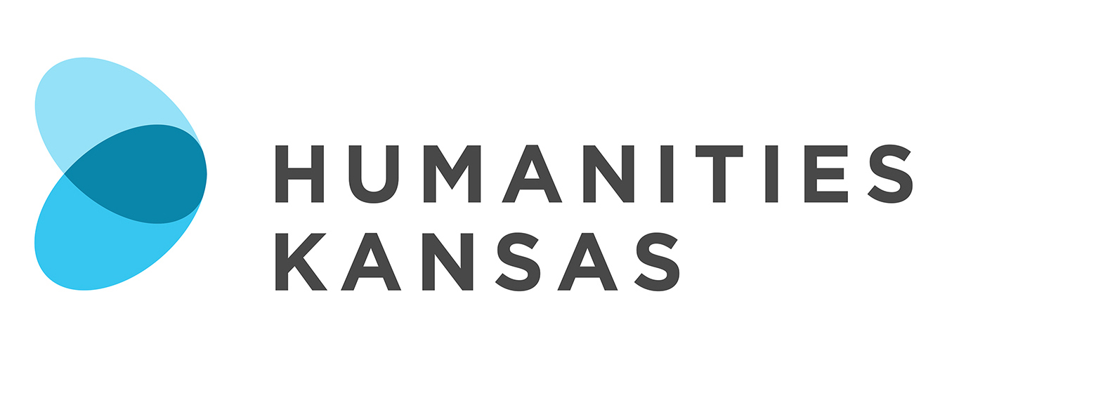

NEWS RELEASE

FOR IMMEDIATE RELEASE FOR MORE INFORMATION:
[DATE] [Insert your information here:
Local Project Director, Title and Organization
Phone Number and Email
Website]

Presentation Explores the Dakota Access Pipeline Controversy

[Community Name] – [Organization Name] in [Community Name] will host “From Fort Laramie to Standing Rock: The Dakota Access Pipeline Controversy,” a presentation and discussion by Jay Antle on [Date] at [Time] at [Location and Address of Presentation]. Members of the community are invited to attend the free program. Contact the [Host Organization Name] at [Phone Number] for more information. The program is made possible by Humanities Kansas.

[List any details about local event here]

For most Americans, the debate over the Dakota Access Pipeline comes down to images of protesters facing off against militarized police, or perhaps Facebook memes supporting one side or the other. This talk will take a step back from more recent contested events to trace the historical origins of divergent ideas about land use, Federal Indian Law, energy development, tribal self-determination, and national politics that set the stage for these events. This talk will use a number of maps and legal documents to provide context for the audience that will encourage thoughtful discussion of these issues.

Jay Antle teaches history and serves as executive director of the Center for Sustainability at Johnson County Community College.

“For the Lakota and other Indian nations impacted by the pipeline, this is simply part of long history of resisting what they see as desecration of the earth,” Antle said.

“From Fort Laramie to Standing Rock: The Dakota Access Pipeline Controversy” is part of Humanities Kansas's Movement of Ideas Speakers Bureau, featuring presentations and workshops designed to share stories that inspire, spark conversations that inform, and generate insights that strengthen civic engagement.

-MORE-

Page 2 – Presentation Explores Irrigation in Kansas

For more information about “From Fort Laramie to Standing Rock: The Dakota Access Pipeline Controversy” in [Community] contact the [Host Organization] at [Phone Number] or visit [Website].

About Humanities Kansas
Humanities Kansas is an independent nonprofit spearheading a movement of ideas to empower the people of Kansas to strengthen their communities and our democracy. Since 1972, our pioneering programming, grants, and partnerships have documented and shared stories to spark conversations and generate insights. Together with our partners and supporters, we inspire all Kansans to draw on history, literature, ethics, and culture to enrich their lives and serve the communities and state we all proudly call home. Visit humanitieskansas.org.

###

