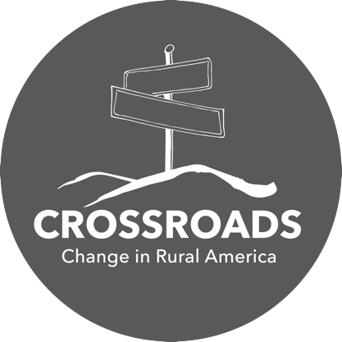
Visitor Survey

- Home city and state:

- Why did you visit today?
to see the Smithsonian exhibition
to attend a special program:
other:

- How did you hear about the project?
newspaper
social media
friend or relative
newsletter
radio announcement
poster
other:

- How many times during the last year have you visited this venue?
first time two or more

- Are you visiting from out of town?
yes no (skip rest of question)

5a. If yes, how many miles did you travel?
less than 100 miles more than 100 miles

5b. If yes, as part of your visit, will you [check all that apply]:
spend the night
shop
eat at least one meal
visit another cultural institution

- Do you live in a rural community?
yes no

- What is one change you would like to see in your rural community?

To receive more information about our organization and to sign up for Humanities Kansas e-newsletter, please leave your name and email address.

Name:

Email:

Humanities Kansas

