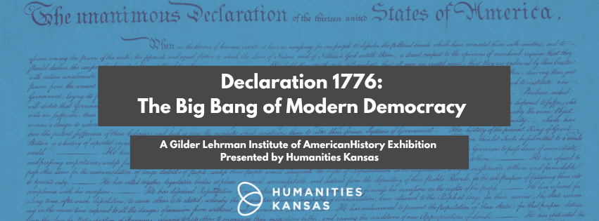
Your Logo Here & Contact Information Here
Venue

Dates

Address
Venue

Dates

Address
See the national traveling exhibition!

When the Declaration of Independence was issued, the idea that “all men are created equal” was revolutionary. With this seminal document, the Founding Fathers unleashed an open-ended driving force that would shape modern history. Around the world, other countries have declared independence taking the US Declaration of 1776 as a model.

This traveling exhibition uses primary sources to illustrate how Americans and people across the world have been inspired by the Declaration in their pursuit of equality and self-determination. A special exhibit panel on “Kansas” in 1776 is also included.
When the Declaration of Independence was issued, the idea that “all men are created equal” was revolutionary. With this seminal document, the Founding Fathers unleashed an open-ended driving force that would shape modern history. Around the world, other countries have declared independence taking the US Declaration of 1776 as a model.

This traveling exhibition uses primary sources to illustrate how Americans and people across the world have been inspired by the Declaration in their pursuit of equality and self-determination. A special exhibit panel on “Kansas” in 1776 is also included.
Your Logo Here & Contact Information Here
See the national traveling exhibition!

Your Logo Here & Contact Information Here

