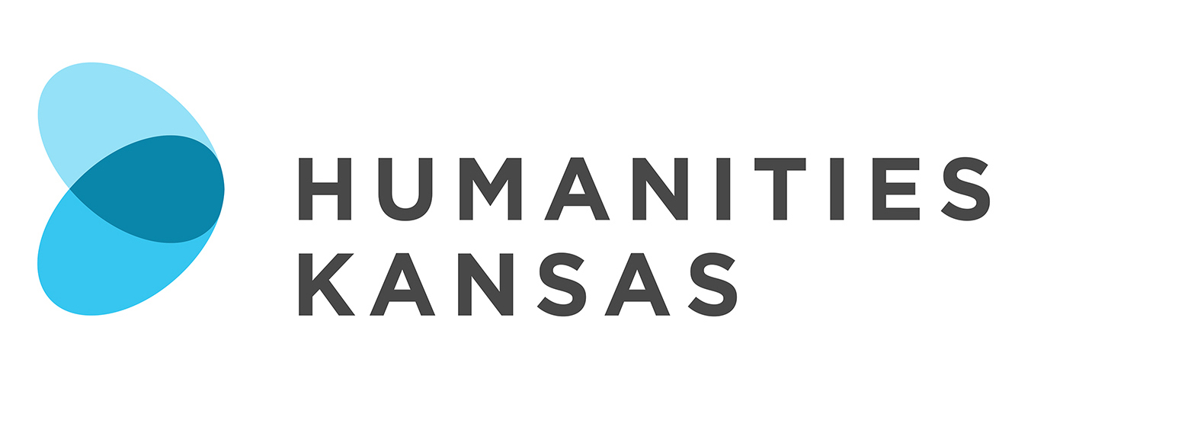

NEWS RELEASE

FOR IMMEDIATE RELEASE FOR MORE INFORMATION:
[DATE] [Insert your information here:
Local Project Director, Title and Organization
Phone Number and Email
Website]

Community Writing Workshop Inspired by Freedom of Speech

[Community Name] – [Organization Name] in [Community Name] will host a Community Writing Workshop facilitated by Paula Ripple on [Date] at [Time] at [Location and Address of Presentation]. Members of the community are invited to attend the free workshop. Contact the [Host Organization Name] at [Phone Number] for more information. The program is made possible by Humanities Kansas.

[List any details about local event here]

The Community Writing Workshop is part of a statewide series of programs that celebrate 100 years of the Pulitzer Prizes and the life of William Allen White. In 1922, the Emporia Gazette editor wrote “To An Anxious Friend,” an impassioned defense of freedom of speech during trying times. For his editorial, he became the first Kansan to be awarded the prestigious Pulitzer Prize.

Just as White defended free speech “by voice, by posted card, by letter, or by press,” Community Writing Workshop participants will be welcome to express themselves through essays, poems, letters, memoirs, fiction—any way they so choose. The workshop is designed to be creative and fun.

Paula Ripple taught English composition at Dodge City Community College and Dodge City High School and has served as a mentor to new writing teachers. In retirement she continues to explore writing and innovative techniques employed by contemporary writers.

“Defending freedom of speech in today’s world is not an outdated idea and is, in fact, demanded in our current political atmosphere,” said Ripple. “With William Allen White as our inspiration, we will endeavor to continue to uphold our right to freedom of speech with forms of writing that use our talents of expression.”

-MORE-
Page 2 – Writing Workshop Inspired by Freedom of Speech

The Community Writing Workshop is part of The Pulitzer Project in Kansas: William Allen White and Freedom of Speech, a joint venture of Humanities Kansas, the Pulitzer Prizes Board, and the Federation of State Humanities Councils in celebration of the 100th anniversary of the Pulitzer Prizes. The initiative seeks to illuminate the impact of journalism and the humanities on American life today, to imagine the future, and to inspire new generations to consider the values represented by the body of the Pulitzer Prize-winning work.

For more information about the Community Writing Workshop in [Community] contact the [Host Organization] at [Phone Number] or visit [Website].

About Humanities Kansas
Humanities Kansas is an independent nonprofit spearheading a movement of ideas to empower the people of Kansas to strengthen their communities and our democracy. Since 1972, our pioneering programming, grants, and partnerships have documented and shared stories to spark conversations and generate insights. Together with our partners and supporters, we inspire all Kansans to draw on history, literature, ethics, and culture to enrich their lives and serve the communities and state we all proudly call home. Visit humanitieskansas.org.

###

