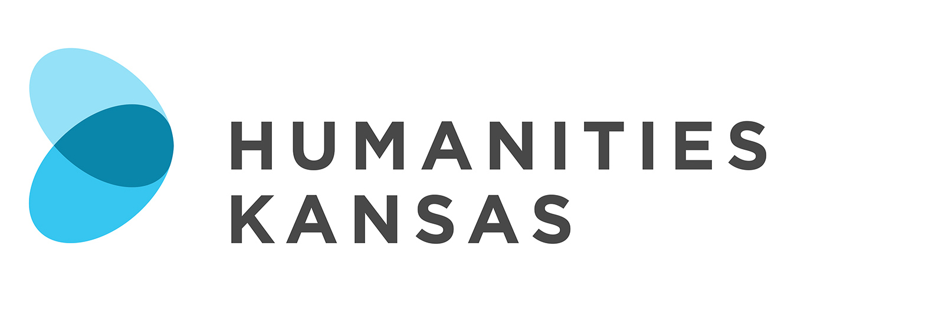

NEWS RELEASE

FOR IMMEDIATE RELEASE FOR MORE INFORMATION:
[DATE] [Insert your information here:
Local Project Director, Title and Organization
Phone Number and Email
Website]

Presentation Focuses on the Sociohistorical Impacts of Invading Indigenous Lands

[Community Name] – [Organization Name] in [Community Name] will host “‘Wide-Open America?’: Kansas’ Legacies of Conquest,” a presentation and discussion by Kerry Wynn on [Date] at [Time] at [Location and Address of Presentation]. Members of the community are invited to attend the free program. Contact the [Host Organization Name] at [Phone Number] for more information. The program is made possible by Humanities Kansas

[List any details about local event here]

In the mid-20th century, Life magazine published an article that ran with the title “Kansas—Bill White’s State is Wide-Open America.” This idea of Kansas as a rural oasis of freedom has often hidden the history of invasion of Indigenous lands. Examining the history of land grants given to veterans and others, as well as popular political rhetoric around the turn of the 20th century, this presentation explores the continuing impact of conquest on Kansas politics and society.

Kerry Wynn is an Associate Professor of History at Washburn University, and the Director of the Washburn University Honors Program.

“‘Wide-Open America?’: Kansas’ Legacies of Conquest” is part of Humanities Kansas's Crossroads Conversations Catalog, featuring presentations, discussions, and workshops designed to spark conversations in the Sunflower State.

This program is part of the Crossroads: Change in Rural America initiative anchored by the
Smithsonian Institution traveling exhibition of the same name. Crossroads promotes fresh thinking about the history, culture, and future of Kansas.

-MORE-

Page 2 – Presentation Focuses on the Sociohistorical Impacts of Invading Indigenous Lands

For more information about “‘Wide-Open America?’: Kansas’ Legacies of Conquest” in [Community] contact the [Host Organization] at [Phone Number] or visit [Website].

About Humanities Kansas
Humanities Kansas is an independent nonprofit spearheading a movement of ideas to empower the people of Kansas to strengthen their communities and our democracy. Since 1972, our pioneering programming, grants, and partnerships have documented and shared stories to spark conversations and generate insights. Together with our partners and supporters, we inspire all Kansans to draw on history, literature, ethics, and culture to enrich their lives and serve the communities and state we all proudly call home. Visit humanitieskansas.org.

###

